Due: 28/03/2007, Worth 1%

Introduction to HTML Forms and JavaScript

Use HTML and JavaScript to create a web browser hosted calculator with the following interface. The calculator should operate entirely client-side - no submit action is required. All JavaScript code should be contained in a separate file. The display field should be read only, i.e., numbers can only be entered by pressing buttons.

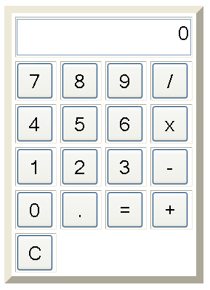

Hints:
- Use a HTML table to layout the buttons.
- You will need JavaScript variables for:
  - the previous value computed (a Number)
  - the operation currently being performed, if any (‘+’, ‘-‘, ‘x ‘or ‘/’).
  - the number currently being entered (a String)
- You can convert Strings to Numbers using the Number constructor.
- Create a JavaScript function for each category of button:

function Digit(ch) {
// for when one of the digit buttons '0' through '9' is pressed.
}

function Equals() {
// for when the '=' button is pressed.
}

function Op(ch) {
// for when one of the operator buttons '/', 'x', '-', '+' is pressed
}

function Clear() {
// for when the clear button 'C' is pressed and also for when the page loads
}

